**LAPORAN PRAKTIKUM**

**PEMROGRAMAN WEB**

**WEEK 2 (Tugas Kampus & Rumah)**



**Disusun Oleh :**

Ahmad Hazli Yahya - 1203222029

**INFORMATIKA**

**TELKOM UNIVERSITY**

**SURABAYA 2024**

**Tugas Kampus :**

Screenshoot kode program dan penjelasan

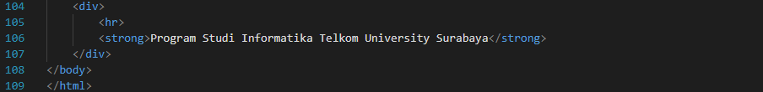

**Output Website :**

**Tugas Rumah :**

Kode dan Penjelasan Program

**Output :**

**Link Github :**

Tugas Kampus & Tugas Rumah Modul 2 : <https://github.com/natalio0/Pemrograman-Web-Modul02>